Week 5 Assignment

Yunjia Zeng

**Part 1:**

1)

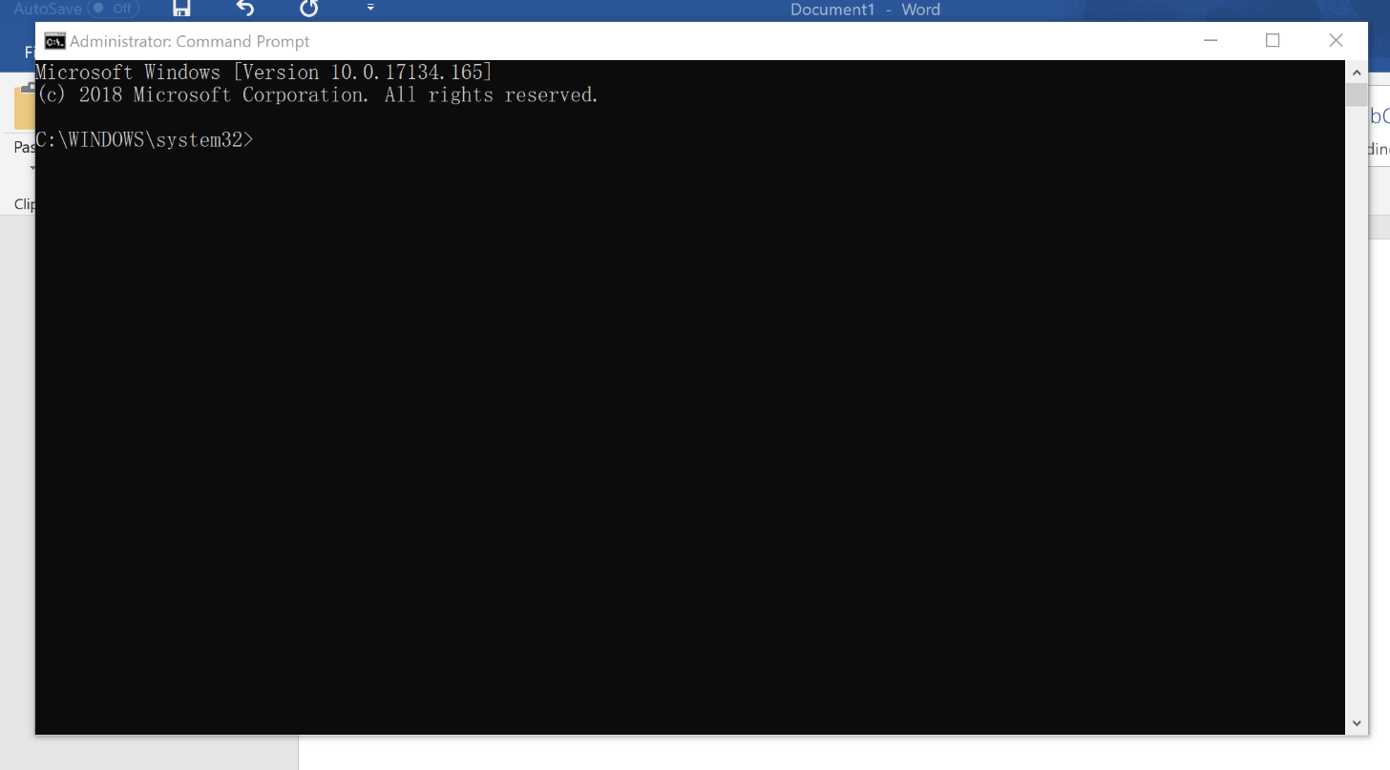

2)

**Command:**

**1 – d: (To drive D:/)**

**2- cd Adv.program (Acturally I used “cd Adv” then hit Tab for auto complete)**

**3- dir (To list all the contents in the current directory)**

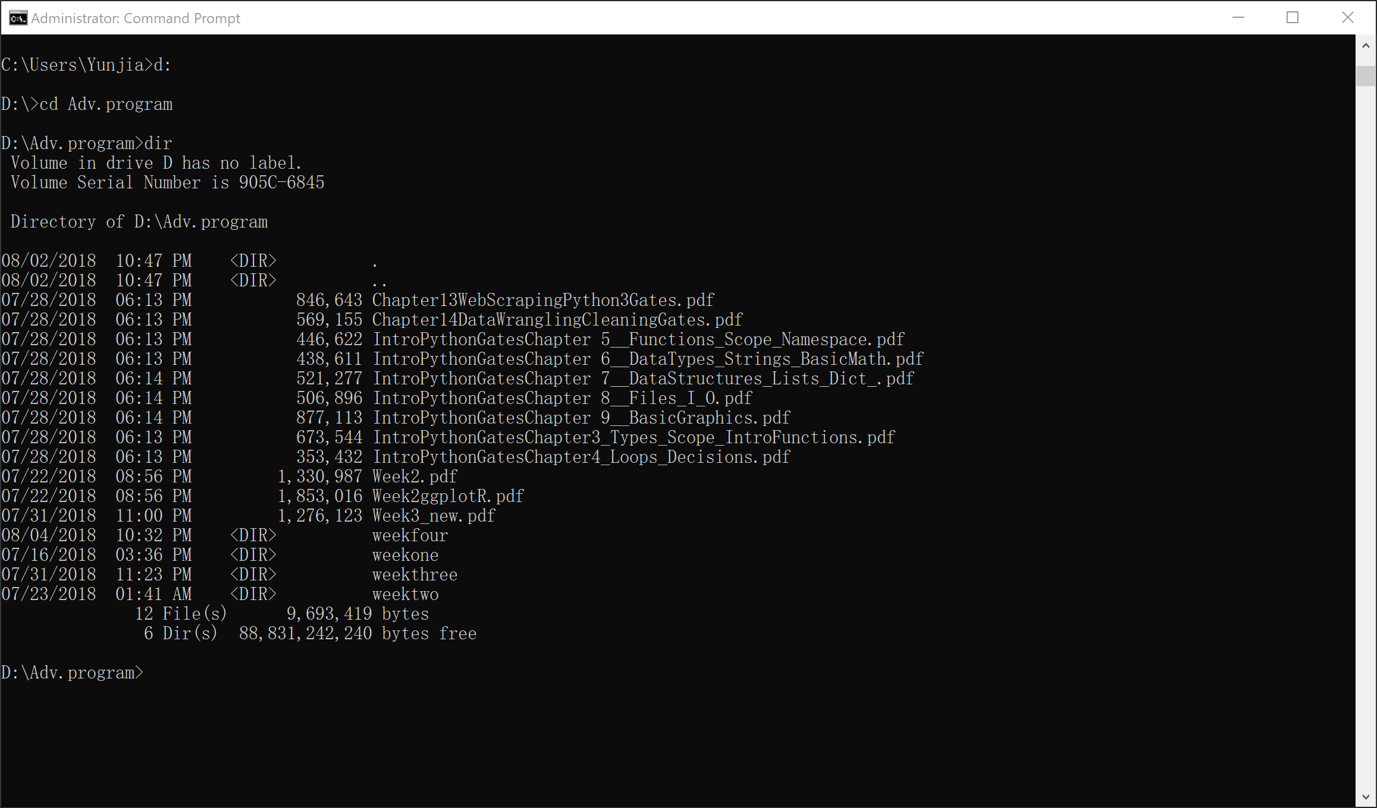

3)

**Command:**

**1 – mkdir MyNewFolder (To create a new folder called MyNewFolder)**

**2 – cd MyNewFolder (change directory to MyNewFolder)**

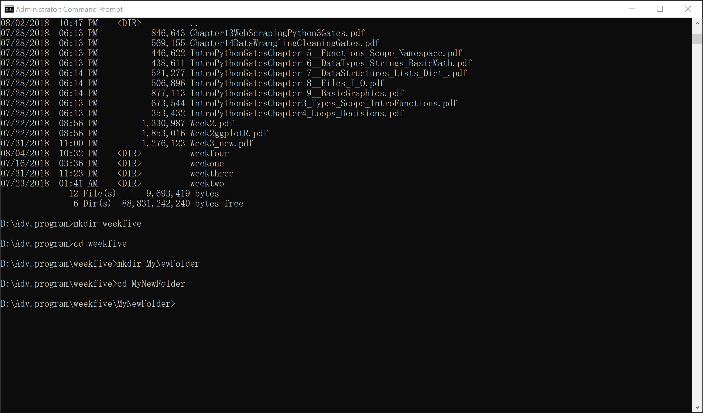

4)

In mybat.bat:

**@echo on**

**cd D:\Adv.program\**

**dir**

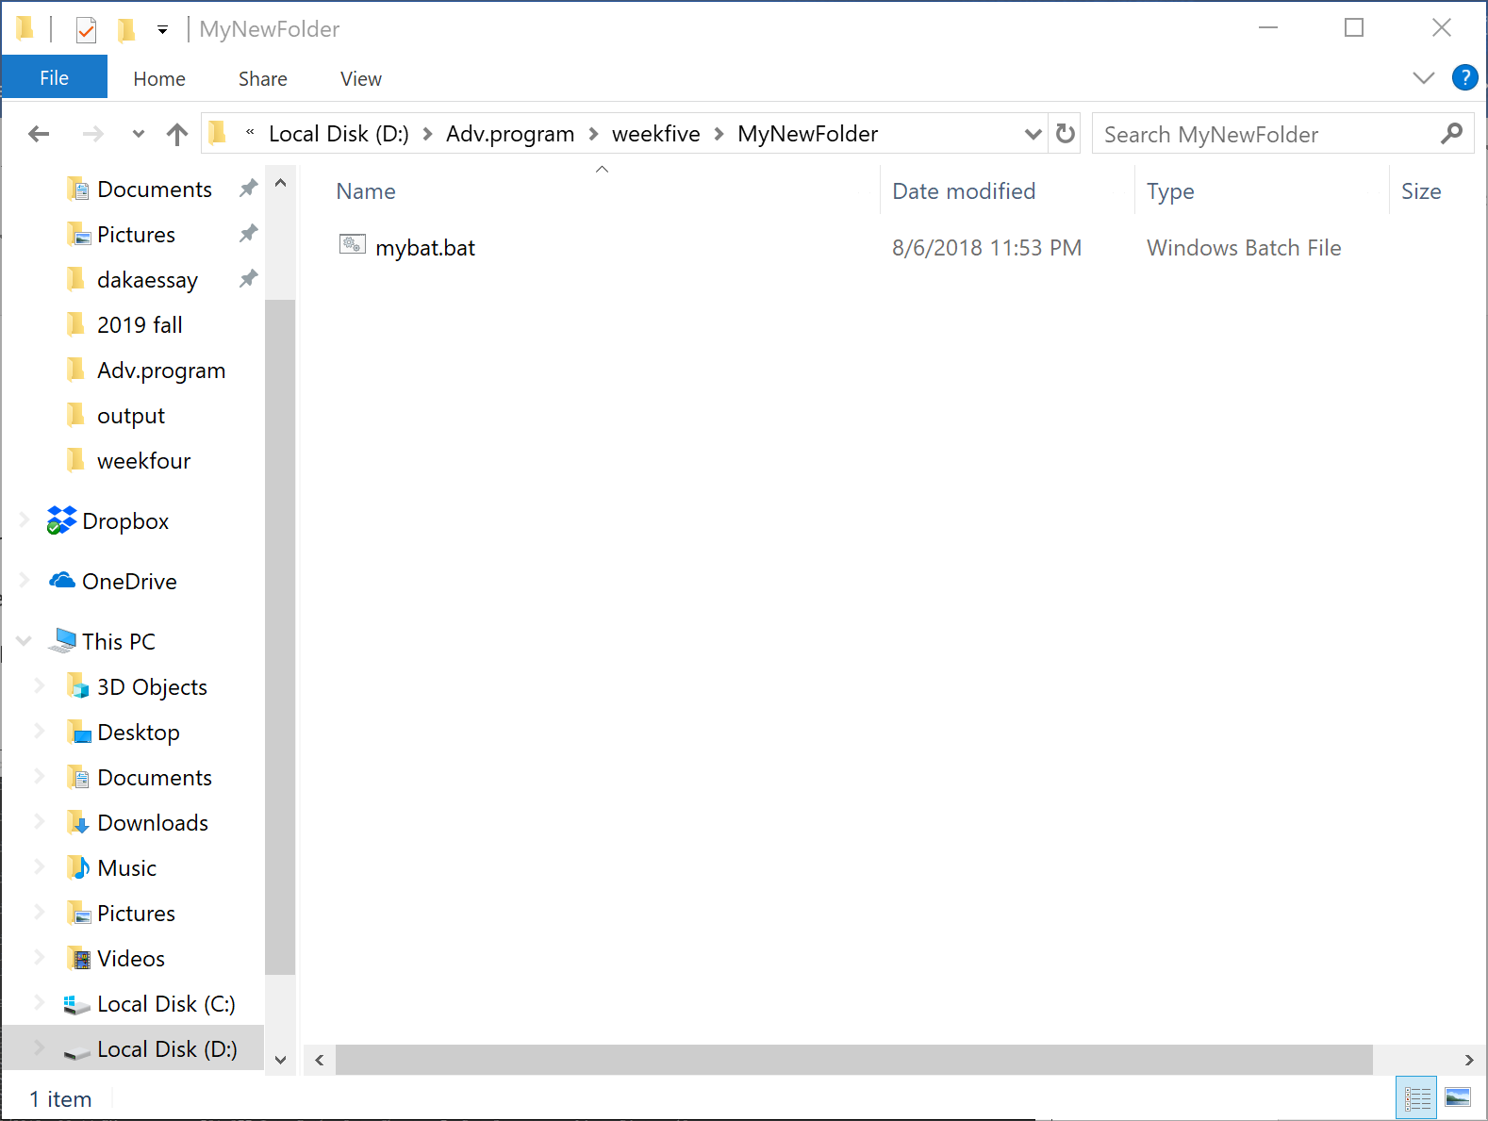

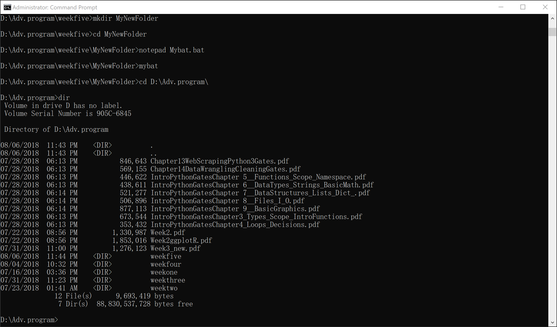

5)

**Command:**

**1 – notepad MyInfo.txt (To create a new .txt file)**

**2 – del MyInfo.txt (To delete MyInfo.txt)**

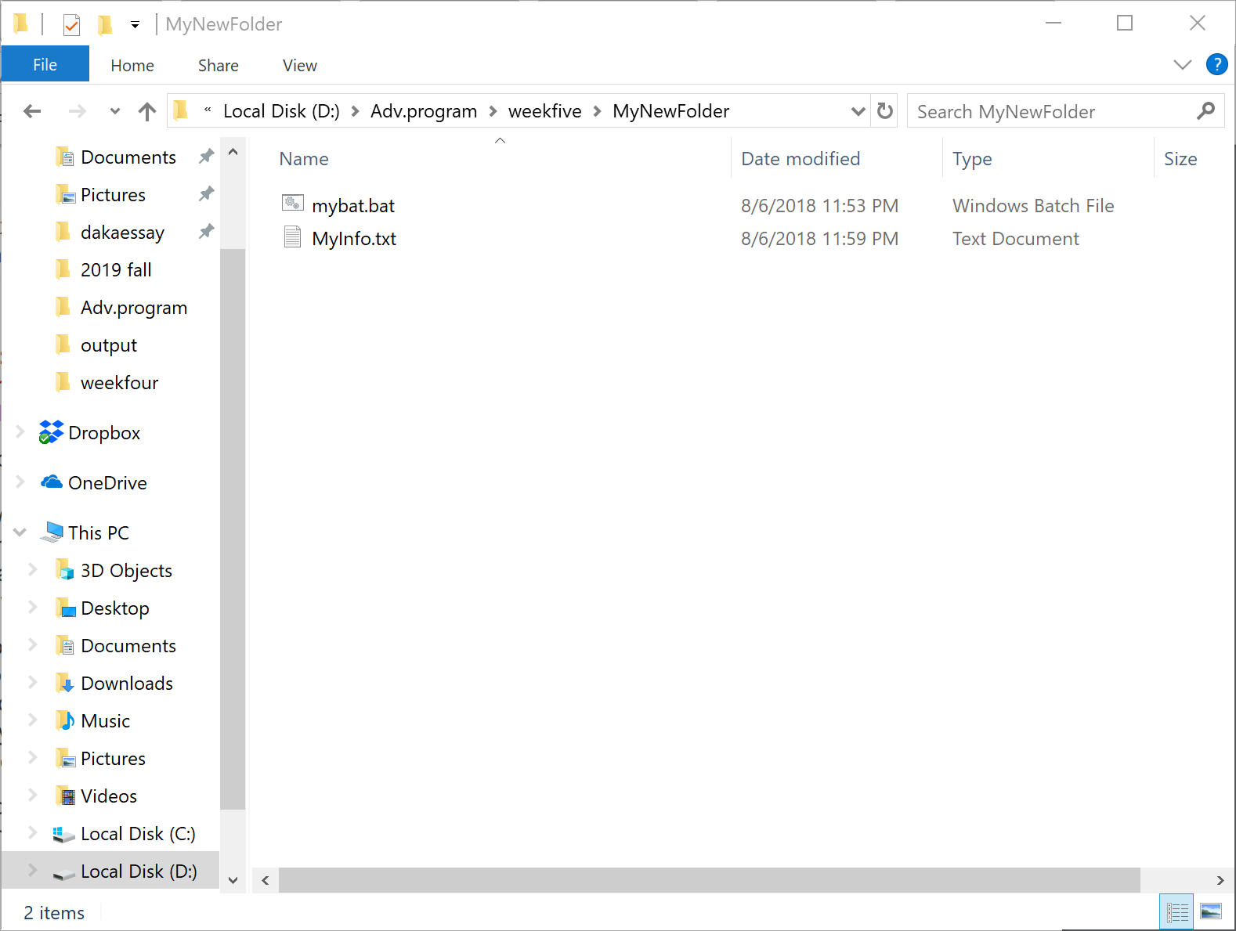

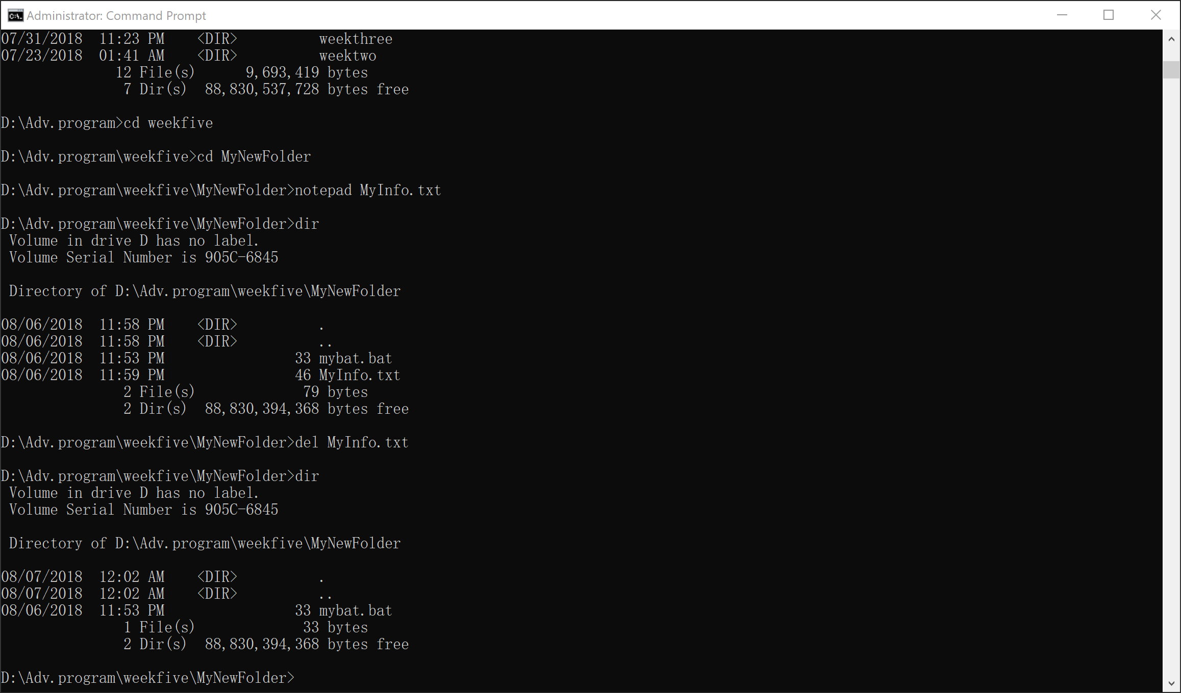

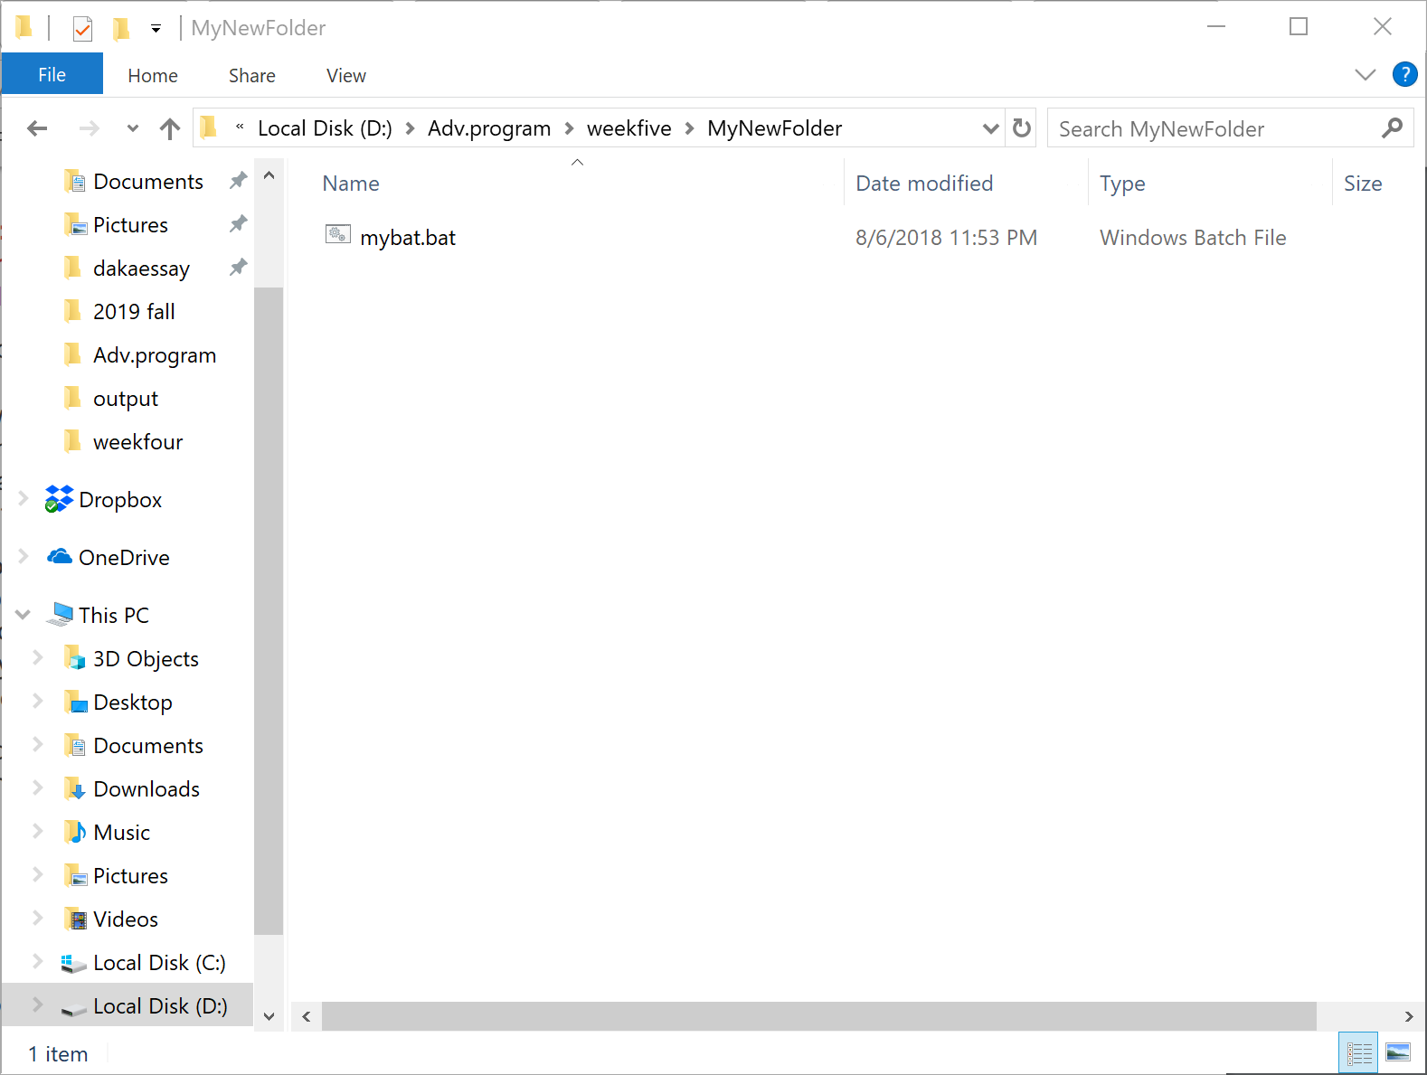

6)

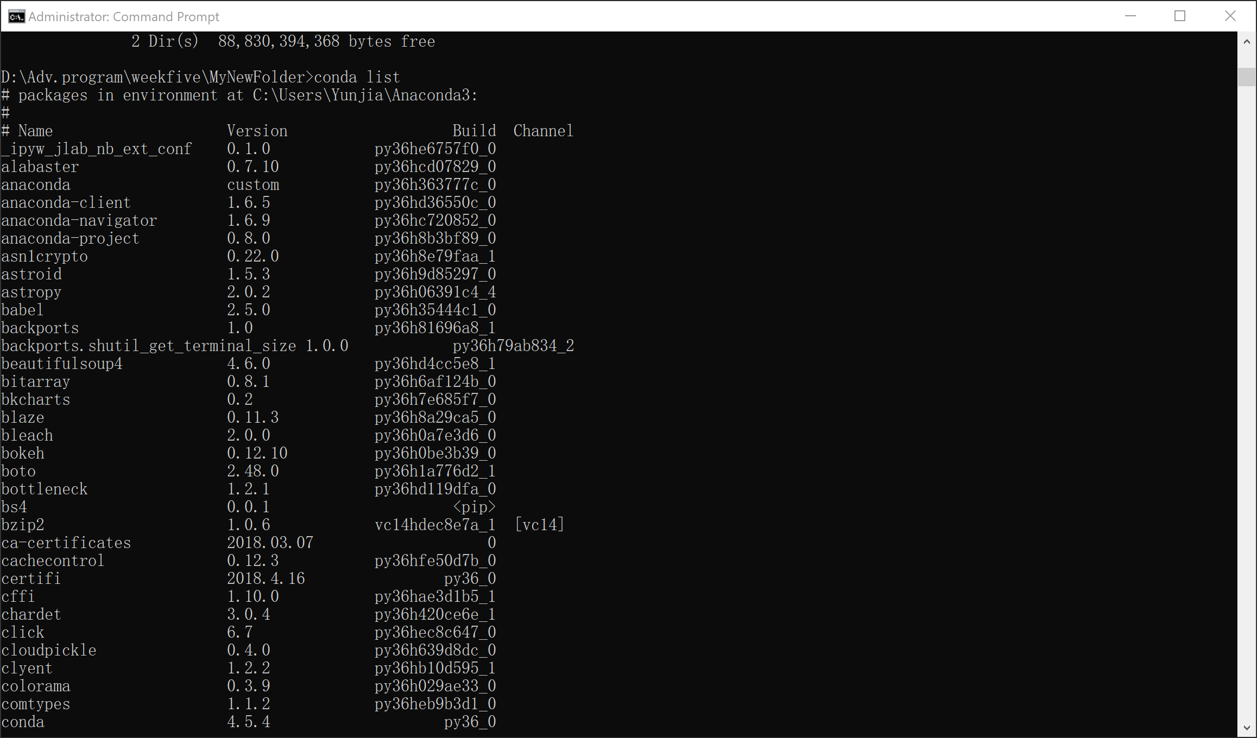

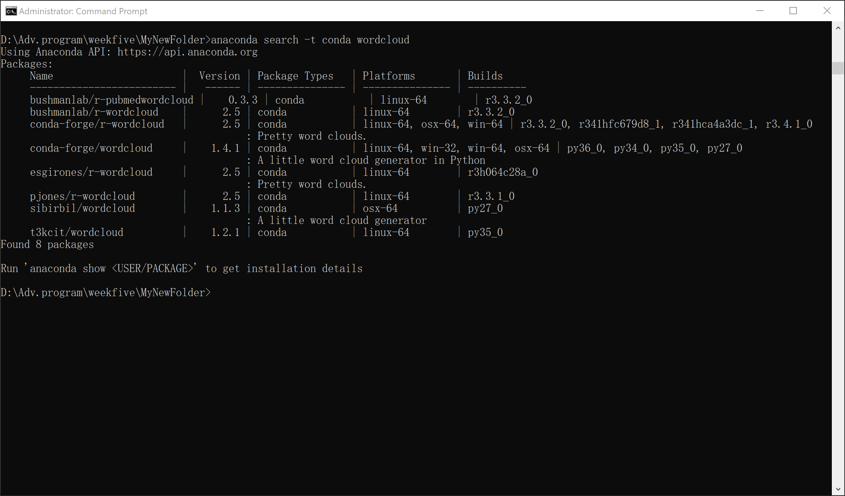

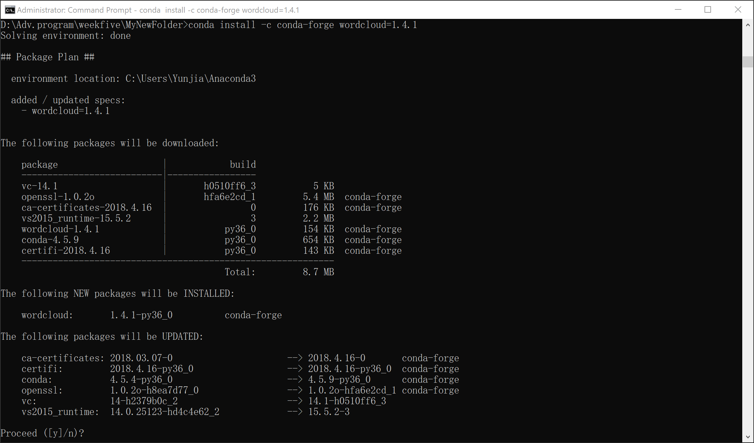

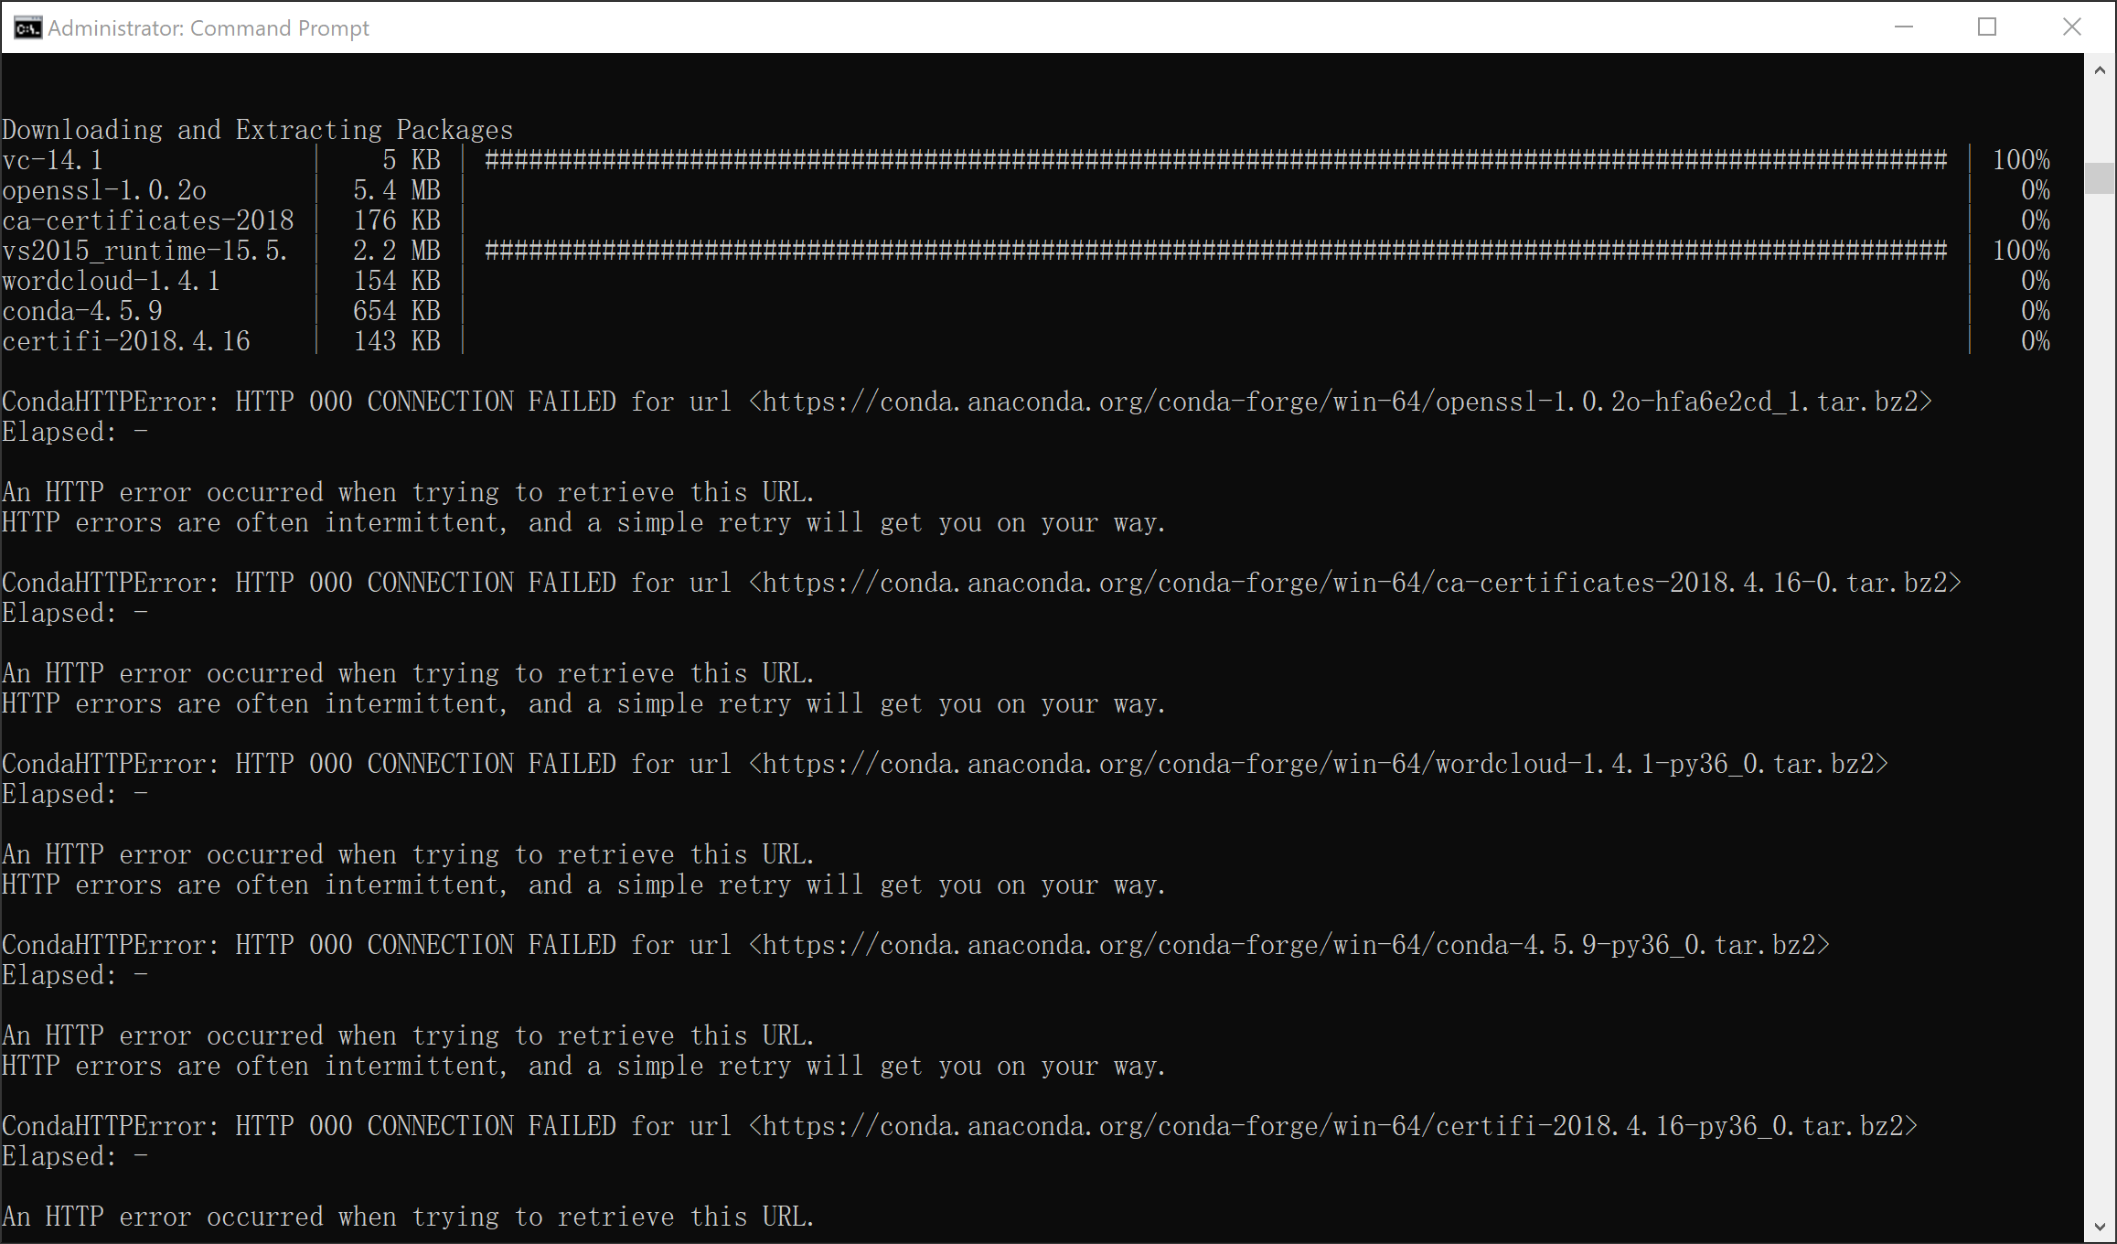

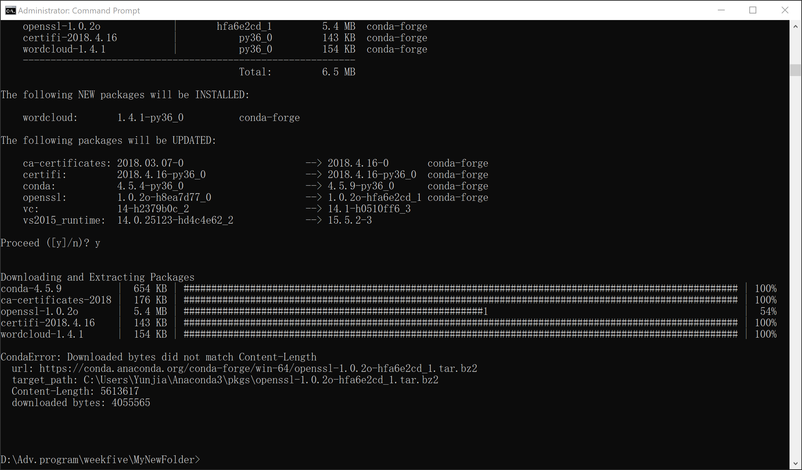

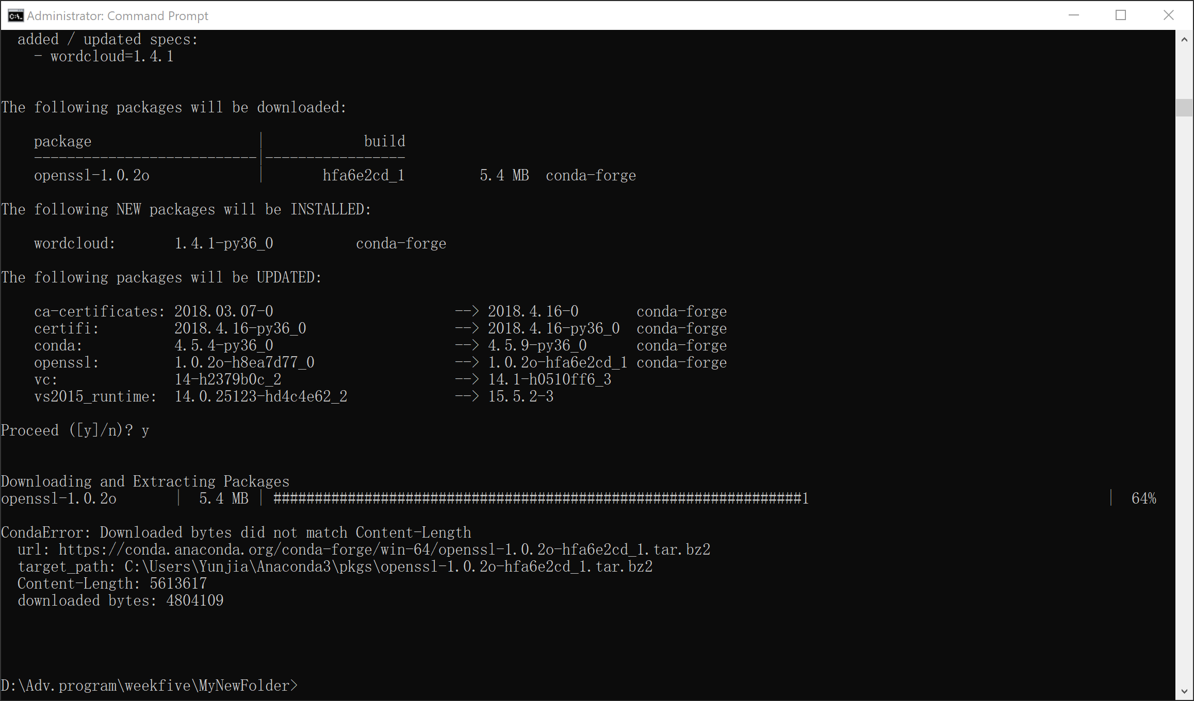

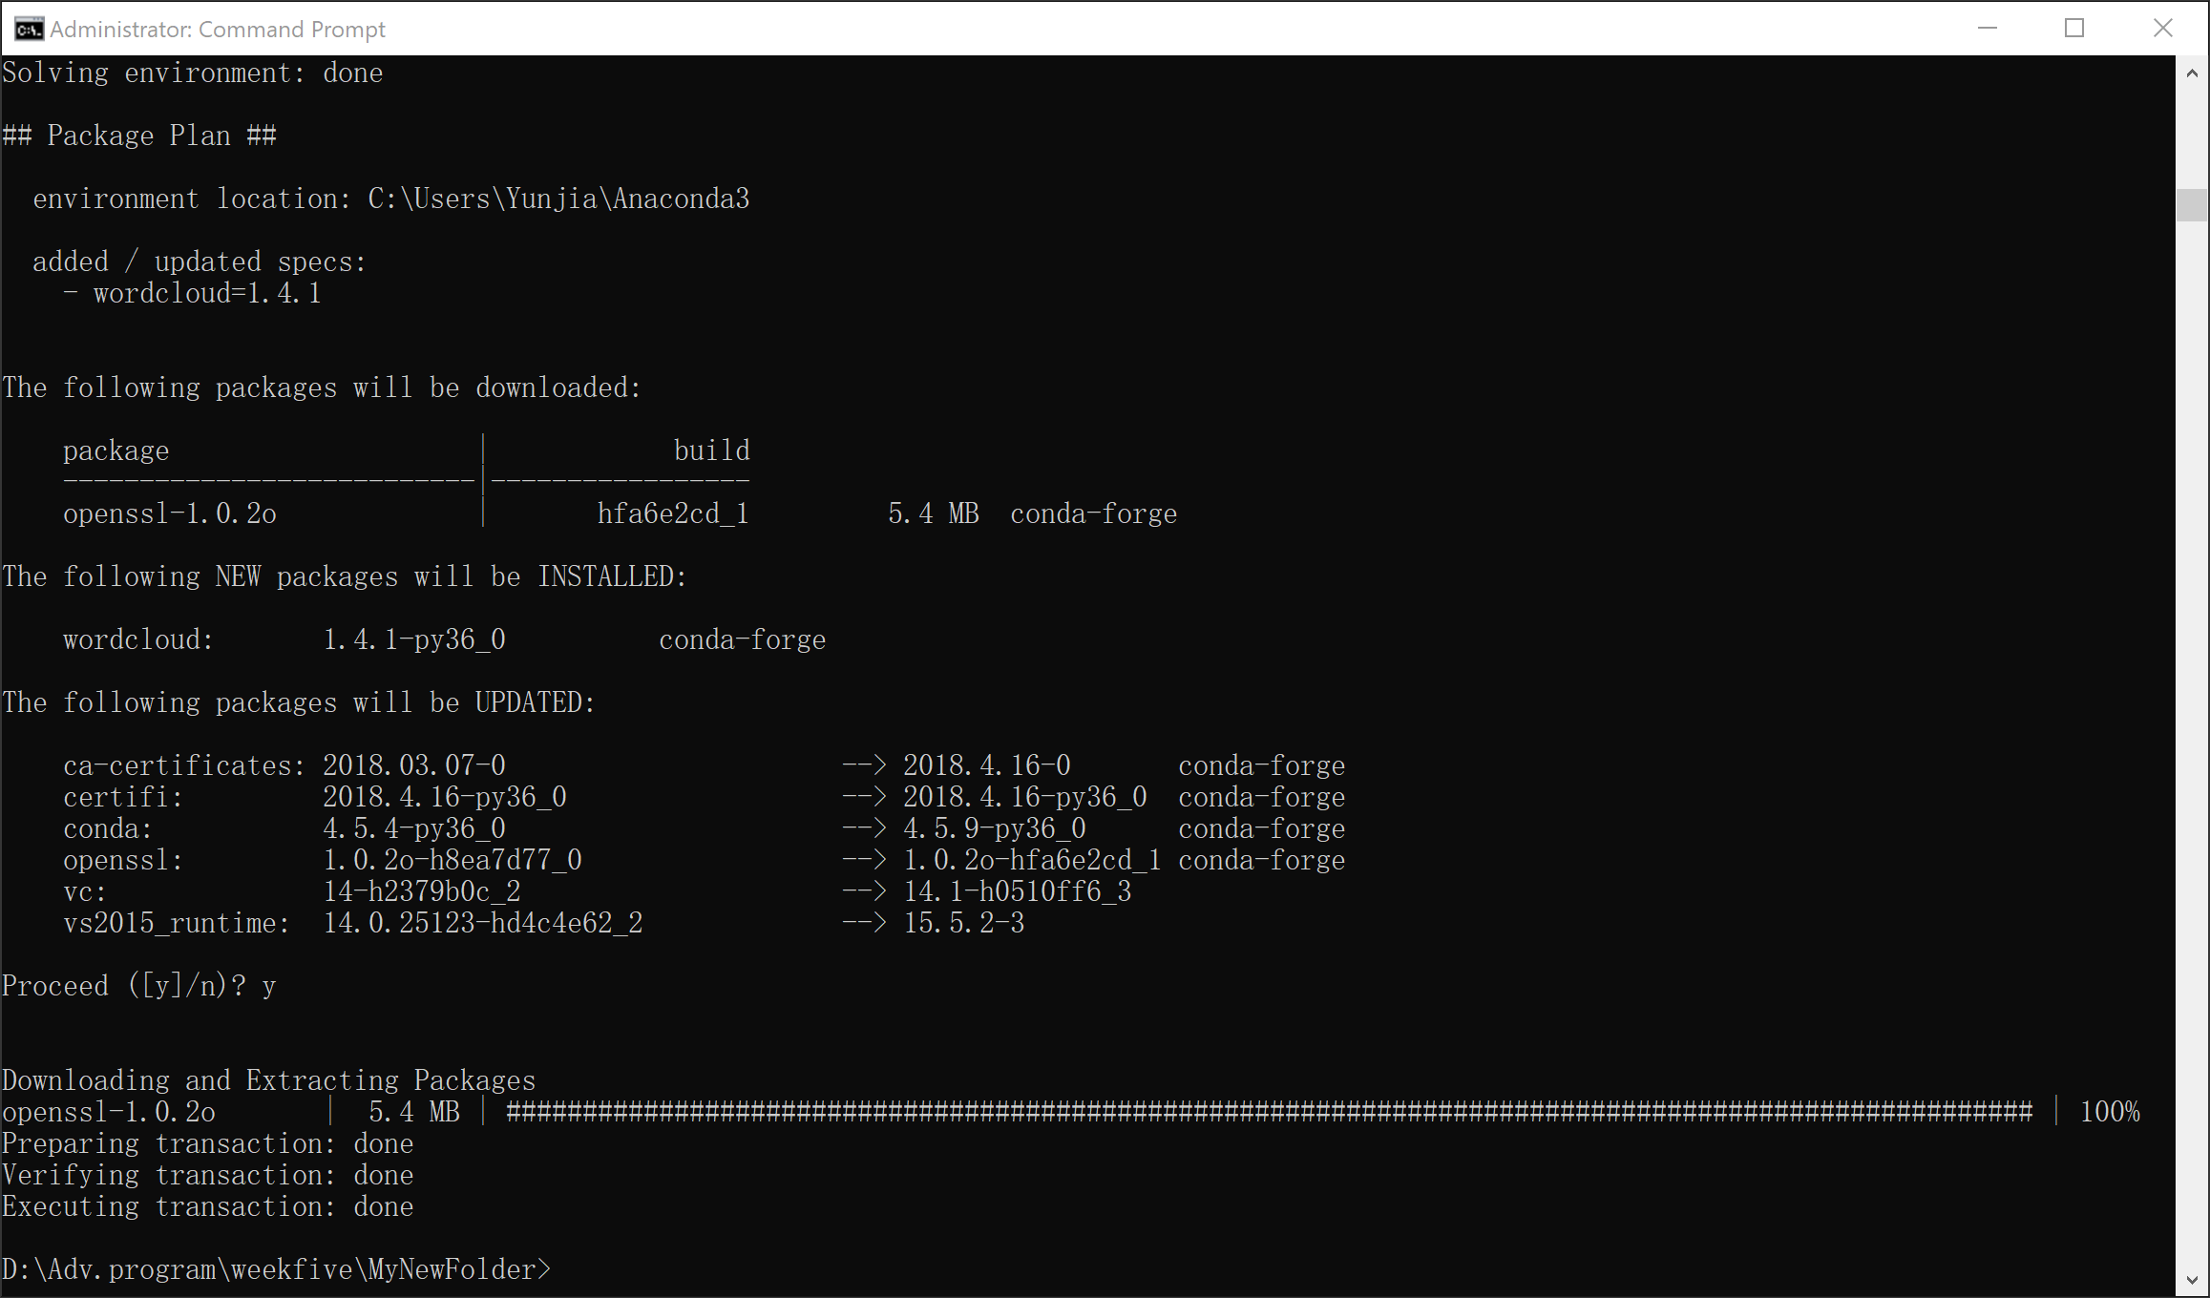

FINALLY!!!!!

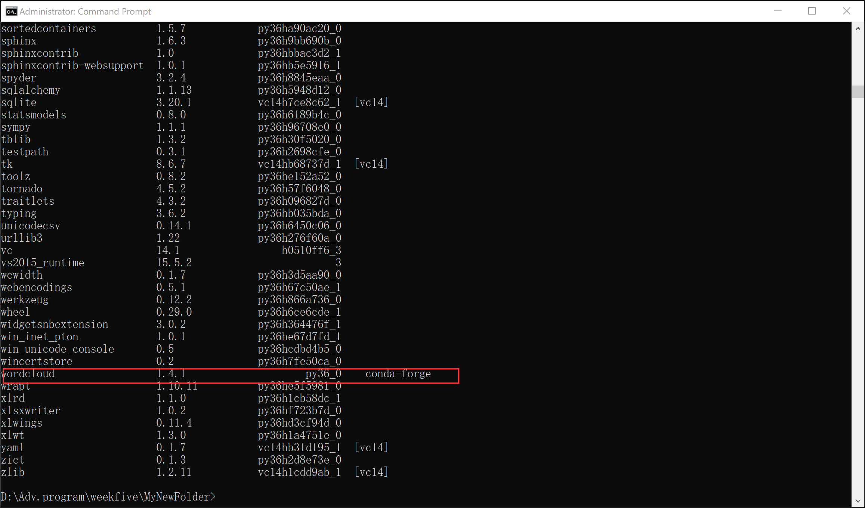

**Part 2**

1)

Both SSH and Telnet are tools for logging in to a multi-user computer from another computer, over a network. SSH is a recent-designed, high-security protocol which uses strong cryptography to protect users’ connection against eavesdropping, hijacking and other attacks. Telnet is an older protocol offering minimal security. SSH allows user to log in to the server without having to type a password, and to connect to the server and automatically send a command so that the server will run that command and then disconnect. Which can be used in automated processing.

2)

Cygwin is free software that provides a Unix-like environment and software tool set to users of any modern x86 32-bit and 64-bit versions of MS-Windows. It provides native integration of Windows-based applications, data, and other system resources with applications, software tools, and data of the Unix-like environment.

3)

**ls:** similar to “dir” in cmd, which list all contents in a directory.

**rm:** a basic UNIX command used to remove objects such as files, directories and symbolic links from filesystems and also special files such as device nodes, pipes and sockets.

**mv:** a Unix command that moves one or more files or directories from one place to another. If both filenames are on the same filesystem, this results in a simple file rename; otherwise the file content is copied to the new location and the old file is removed.

**cp:** a UNIX command for copying files and directories. The command has three principal modes of operation, expressed by the types of arguments presented to the program for copying a file to another file, one or more files to a directory, or for copying entire directories to another directory.

**cat:** allows us to create single or multiple files, view contain of file, concatenate files and redirect output in terminal or files.

**du:** a standard Unix program used to estimate file space usage—space used under a particular directory or files on a file system.

**df:** a standard Unix command used to display the amount of available disk space for file systems on which the invoking user has appropriate read access.

**quota:** displays users’ disk usage and limits. By default, only the user quotas are printed.

4)

**grep:** to search text or searches the given file for lines containing a match to the given strings or words. By default, grep displays the matching lines. Use grep to search for lines of text that match one or many regular expressions, and outputs only the matching lines.

How to use:

1. Create a demo file by command: **cat demo_file**
2. Type following:

**THIS LINE IS THE 1ST UPPER CASE LINE IN THIS FILE.**

**this line is the 1st lower case line in this file.**

**This Line Has All Its First Character Of The Word With Upper Case.**

**Two lines above this line is empty.**

**And this is the last line.**

1. Then search for the given string in a single file using grep: **grep "this" demo_file**
2. Result:

**this line is the 1st lower case line in this file.**

**Two lines above this line is empty.**

**And this is the last line.**